NEW WOMEN'S NETWORK SEEKS TO END GUN VIOLENCE IN THE HOME
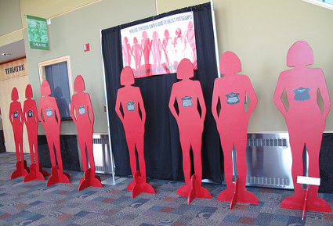
****
AdvocacyNet
News Bulletin 202
June 18, 2009
*****
New Women's Network Seeks to End Gun Violence in the Home
London, UK: Twenty-eight-year-old Paulina Kenamuni recently moved out of her boyfriend's house in Otjiwarongo, Namibia to escape their abusive relationship. On June 4, the man showed up at her mother's house with a hunting rifle, and fatally shot both women.
For a growing number of women around the world, the greatest risk from guns is not on the streets or the battlefield, but in their own homes - and most of the deaths are caused by a close acquaintance. In Portugal, 47 women have been killed in incidents of domestic violence so far this year. Eighty-two percent of the murders were committed by a current or former husband, boyfriend or partner.
This week, women in 28 countries launched the first international campaign to end the threat of armed domestic violence, led by the London-based International Action Network on Small Arms (IANSA). The campaign was unveiled as part of IANSA's Global Week of Action Against Gun Violence (June 15 - 22), which is being observed this year in 85 countries worldwide.
The new network seeks to take guns out of the hands of men who have a history of domestic abuse, and are most likely to use a gun in anger. "If you have a previous record of violence, you simply should not be allowed to own or possess a gun," said Sarah Masters, who coordinates the IANSA Women's Network. "It is shocking that only four countries have taken action to reduce gun deaths in the home."
The Advocacy Project (AP), a partner of IANSA, is supporting the Disarming Domestic Violence campaign by sending Peace Fellows to eight IANSA members - in Argentina, Canada, Colombia, El Salvador, Nepal, Namibia, Portugal, Serbia, and Uganda. The Fellows have been asked to collect information, document the stories of abused women, and create a common database for the campaign.
According to IANSA, women are three times more likely to die violently if there is a gun in the home. For every woman killed or injured by firearms, many more are threatened.
The global nature of the crisis is reflected in the new network, which includes top researchers in Serbia, community advocates in Namibia, and disarmament specialists in Canada. Together, they are demanding that spouses and partners are consulted before a gun license is granted, to ensure that men with a history of domestic abuse are denied access to firearms or have their licenses revoked.
Firearms licensing has already been integrated into domestic violence laws in Australia, Canada, South Africa, and Trinidad and Tobago - with impressive results. Canada tightened its gun laws in 1995, and by 2003 the gun murder rate dropped by 15 percent overall and by 40 percent for women. Australia, which overhauled its gun laws in 1996, saw a 45 percent drop in the murder of women within five years.Pauline Dempers interview
The campaign kicked off this week with a flurry of activities. In Argentina, advocates held a candlelight vigil and met with Argentine Senator Christina Perceval to press for a new bill on armed domestic violence. In Canada, activists brought their message to the First Annual Canadian Conference on the Prevention of Domestic Homicide in Ontario.
Peace Fellow Johanna Wilkie joined Pauline Dempers, the National Coordinator of Breaking the Wall of Silence (an IANSA member) in Namibia, for an interview on Namibia's national radio station. Nepali advocates held a rally Sunday to brief representatives of political parties. Advocates in Serbia launched their campaign with a television appearance Monday (June 15) and a press conference today. Women in Portugal will kick off their campaign June 29 with a documentary screening and discussion.
● Learn more about Disarming Domestic Violence
● Meet the women's network
● Read the blogs of Peace Fellows working on the campaign
● Find Global Week of Action events

