WOMEN ADVOCACY PROJECT

REG N0. MA0001240/16

ANNUAL NARRATIVE REPORT AND FINANCIAL STATEMENT FOR WOMEN ADVOCACY PROJECT
JANUARY – DECEMBER 2016

1110 South View Uplands, Waterfalls
Harare, Zimbabwe
Tel: + 263 775 778 262 or + 263 774 354 604
E-mail: constance.wap@gmail.com

PREPARED BY WAP’S SECRETARIAT

Letter from the Executive Director

Dear Friends and Partners

I am pleased to welcome you to the presentation of our 2016 Annual Report and Financial Statements. Please take it as WAP’s invitation for you as an individual, your organization and friends to join us in our efforts and commitment to help the disadvantaged, discriminated, poor and marginalized women and girls in Zimbabwe to help themselves by empowering them to contribute meaningfully towards the achievement of livelihood sustainability. If WAP is given the necessary support, this effort can significantly contribute to human, social, economic and political development; peace and democratic governance in Zimbabwe and Africa at large.

The year 2016 was both challenging and a success for WAP and for women and girls we serve. For example, for over two decades, Zimbabwe has been experiencing serious socio- economic challenges, resulting in high level of poverty, political instability including long-term economic stagnation, unemployment, inflation, food insecurity, HIV and Aids prevalence, limited provision of basic services including lack of access to education for many children from low income and poor families, power outages, droughts, lack of clean water, violence, and among all, the most affected are women and children.

It is a fact that, Since 1997 Zimbabwe has been experiencing a crisis which has negatively impacted the economic and social situation of its populace. While the current political climate is a bit stable coupled with a peaceful atmosphere; the economic situation in the country continue to further deteriorate. The controversial and highly advertised indigenization and black empowerment policy designed to empower indigenous Zimbabweans with at least a 51% local shareholding and every enterprise with a market value of over $ 500.000 has not been consistent with the international liberalized and open market economic policies that motivate investors to maximize on profits while creating employment. This has led in the closure of most foreign companies and reluctance to invest more capital in Zimbabwe, resulting in the decline of economic growth. Meanwhile, Zimbabwe’s industry is declining with less than 16% fully operational, while most state enterprises are grounded to a halt due to capital challenges, brain drain and obsolete equipment. This resulted in high unemployment rate estimated at above 80%. Of the 20% that are in formal jobs, the majority of them are under employed. Most affected are women and girls, they constitute the majority (over 52%) of the population and are living in abject poverty, unemployment, vulnerability with house hold food and income insecurity. In addition, many children are dropping out of schools because parents cannot afford to pay school fees. This is considering that basic education in Zimbabwe is no longer for free. School fees are beyond the reach of most poor and low income families leaving more than 1 million children between 6 to 15 years without schooling.

This situation has led many parents and guardians especially those who are poor to force their young girls to be married before they mature to the age of 18 years. For many poor families in Zimbabwe, it has become a strategy essentially for economic survival to marry their daughter at an early age; it means one less person to feed, clothe and educate. The importance of financial transactions at the time of marriage tends to push families to marry their daughters early as parents get a high bride price for a daughter who is married. Child marriage has predominantly affected girls who live in poverty. Girls from the poorest households are more than 4 times likely to be married/ be in union before age 18.

In addition, lack of education for girls has been described as another main factor of forced early child marriage in Zimbabwe. Little or no schooling strongly associates with being married at a young age. On the contrary, attending school and having higher levels of education protect girls from the possibility of early marriage. Yet, in many areas of Zimbabwe, especially rural communities, educating a girl child often is less of a priority than educating a boy child. This is because culturally, Zimbabweans believe that a woman’s most important role is considered to be that of a wife, mother and homemaker. Schooling girls and preparing them for the jobs is given very little attention. And even when poor families want to send their daughters to school, they often lack access to nearby, quality schools and the ability to pay school fees. Parents feel that it is usually safer and economically more rewarding to spend their limited resources on educating sons than daughters, which leads many families into early marriage as the only viable option for girls.

On the other hand, religion has also been described as a driver of child marriage in Zimbabwe. For example, in the apostolic faith, religion combines with traditional culture, and girls are often encouraged to marry much older men at a very young age. This situation is unacceptable, and has negatively impacted the lives of young women and girls in homes, families and communities, not only in Zimbabwe, but also Africa and the world as a whole.
To this end, the Women Advocacy Project is kindly appealing to the Government of Zimbabwe, international community, NGOs, Civil Society and local leaders to seek ways to eliminate the prevalence of child marriage in Zimbabwe, increase educational opportunities for poor and non-schooling girls living in poverty to be able to attend school through the provision of scholarship and bursaries. Applying stiffer penalties and sentencing of violators, and create ways to help improve the socio economic empowerment for disadvantaged and marginalized families in communities.
We want to express our profound gratitude to all our Development Partners in the country and beyond for their support throughout the year. Financial support were received from the Rock Flower (USA), Stichting Overal (Netherlands), Stichting Alert Fund for Youth (Netherlands) and X Min Y Solidarity Fund (Netherlands). Without this support, our work this year would not have been possible. We also want to thank our staff at WAP for providing leadership, coordination and management to the whole designed programme for implementation in year 2016. Our sincere appreciation also goes to the Ministry of Women’s Affairs, Gender and Community Development (Government of Zimbabwe), leaders and communities in Harare and Marondera, the Women’s Self Promotion Movement, Child Line Zimbabwe, Zimbabwe Republic Police, Denmark Training Services, Upper View College, Mbare High School, Mabvuku High School, Inspired Teens, young women victims of forced early child marriage and Hopley High School for cooperating with and supporting our initiatives. We submit this report to you all for your use and reference in your invaluable work. We hope it will light your way as you search for lasting measures in addressing priority issues keeping many of our households vulnerable.

Please, consider partnering with us through your donations and support to help us continue helping and empower affected, vulnerable women and children in Zimbabwe.

Thank you

Constance Mugari

I. Background information of the Organization:
I.1. Who we are:
Women Advocacy Project is a registered non-governmental, not for profit making Trust for women empowerment. The organization was created by a group of women from different communities of Harare. WAP was established after the realisation of inadequate attention given to the issues that are affecting women and girls. The organisation is committed at promoting and protecting the rights of vulnerable and marginalized women and girls in communities through holding advocacy campaigns and lobbying for the right of voiceless women and girls. WAP also seek to promote women’s socio-economic rights through the implementation of socio economic empowerment projects.

Our Vision: WAP’s vision is a society where women and girls realize, enhance and maximize their social, cultural, economic and political potential as citizens of Zimbabwe.

Our Mission: WAP’s fulfills its mandate through holding advocacy campaigns on women human rights, provide training and leadership capacity building workshops and facilitating economic empowerment for disadvantaged and marginalized women and girls in Zimbabwe.

Our Objectives:
WAP’s objectives are:
- To enhance women’s resilience to external shocks, engage in sustainable livelihoods, improved access to and benefit sharing of resources in Zimbabwe;
- To support women in establishing and accessing markets for their products and produce;
- To promote human rights and gender awareness through advocacy, training and exchange;
- To contribute to development research and publications on women and children in Zimbabwe;
- To coordinate and network with other organizations with similar objectives in and outside Zimbabwe.

Our Main focus areas include:
- Human rights, gender, leadership and HIV/AIDs awareness
- Capacity building, education, lobby and advocacy
- Commemorations and networking
- Women’s economic empowerment

WAP’s Administrative Structure:
At the current moment, Woman Advocacy Project is composed of 26 members and its Administrative structure is as follows:
1. General Assembly,
2. Council of Administration or Board of Management (BOM) Composed of 7 members namely Chairperson, Vice Chairperson, Secretary, treasurer, Director and two advisors,
3. Coordination or Executive Committee.
Please, note that due to limited financial resources WAP’s staff or members are currently working on voluntary and part time basis.

II. Our Achievements in year 2016
During the year 2016 WAP managed to implement the following activities:
- Two “Give us Books, Not Husbands” Child Marriage Abolition Campaigns. One in Hopley and another in Waterfalls
- Entrepreneurship, Business Leadership and Management Training Workshop in Marondera
- Women’s Economic Empowerment through Raising Broiler Chickens for Households’ Sustenance Project in Marondera.

II.1. A. “Give Us Books, Not Husbands” Child Marriage Abolition Campaigns in Hopley
Child marriage remains a growing threat to the basic human rights and protection of children in Zimbabwe, and calls for appropriate measures to be taken to abolish traditional practices prejudicial to the health of children with reference to other children’s rights that are connected to child marriage, such as the right to freedom of expression and the right to protection from all forms of abuse. The Convention on the Elimination of all Forms of Discrimination against Women (CEDAW) prohibits child marriage and the Universal Declaration of Human Rights (UDHR) recognizes the right to free and full consent to marriage.
In the case of child or early marriage in Zimbabwe, at times parents consents on behalf of their children as they are considered to be too young to make their own decision for themselves. Both boys and girls are involved in child marriage; however, girls more often face adverse effects on their mental, physical and emotional growth. The issue of child marriage is widespread especially in areas where poverty is rampant and families lack access to alternate opportunities such as income-generating and educational programmes. In most cases, girls can be seen as an asset from which families can gain property and livestock from bride wealth exchanges. Other factors that lead to the ongoing practice of child marriage include ingrained gender bias, with a preference for sons; inadequate laws; and observance of traditional/cultural/religious practices and belief such as payment of a bride price. Early marriage has become a strategy for survival for many families across the country, whether it is relieving them of a burden or receiving a form of payment to support them.
Child marriage perpetuates the cycle of poverty and gender inequality and blocks the potential of girls and women. Despite laws prohibiting marriage before the age of 18, Zimbabwe has one of the highest rates of child marriage on the African continent. According to UNICEF- Zimbabwe, in 2016 alone, about 34% of girls were married by 18, while 4% were married by 15 in Zimbabwe. (http://www.girlsnotbrides.org/child-marriage/zimbabwe/). The impact of child marriages for girls goes beyond the obvious end to a career path. Child marriage brings an abrupt and unnatural end to a girl’s childhood and adolescence through imposing adult roles and responsibilities before she is physically, psychologically and emotionally prepared. Marriage imposes social isolation on girls, bringing unwanted separation from their friends and family. Once married, girls are most likely to feel powerless to refuse sex. Child brides find it difficult to insist on condom use by husbands who are usually older and more sexually experienced making the girls vulnerable to HIV/AIDS including other STIs. Child marriage can result in bonded labour or enslavement. Child brides are also under intense pressure to fall pregnant immediately after marriage presenting a major risk for both mother and the baby.
In response to the above situation, with financial support from Alert Fund for Youth (Netherlands) and X min Y Solidarity Fund (Netherlands) Women Advocacy Project managed to implement its first “Give Us Books, Not Husbands” Child Marriage Abolition campaign on 23rd July 2016 in the community of Hopley in Harare. Please see a picture as given below.
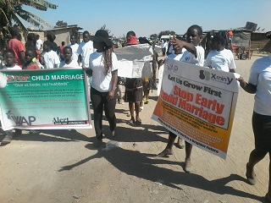
This campaign in Hopley was attended by 85 young women and girls students from Hopley primary and secondary school, teachers, victims of forced early child marriage, Zimbabwe Republic police officers, local authorities, church and community leaders and activists from other women community based organizations. See a picture below showing the vice counselor of Hopley giving a speech at a gathering during the march

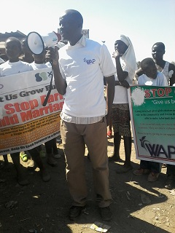

II.1.B. Aim and Objective of the Awareness Campaign.
This campaign sought to:
- Speak on the elimination of child marriage in Zimbabwe,
- Inform the community effects that child marriage has impacted in the victims live,
- Ask the government to consider creating educational opportunity for non-schooling and girls from poor families, and
- Ask the government to allow the rule of law on cases concerning child marriage.
II.1.C. Activities Involved.
Activities that were held during our campaign in Hopley include the following:
- A 3 Km street walk,
- Drama by Hopley Primary School Students, and
- Speech by Hopley Deputy Councilor
II. 1. C. A. 3 Km Street Walk.
The awareness campaign in Hopley began with a 3 kilometer street walk which covered the distance between Zone 5 to Zone 3 in Hopley and it was attended by all participants including Pastors, young mothers’ victims of forced early child marriage, all students and Teachers present, and Zimbabwe Republic Police Officers. During the street walk, participant managed to have face to face conversations with community members residing in the area and those who were passing in the streets. Participants also walked while chanting expressing the need to stop child marriage. Please, see a picture as given below.
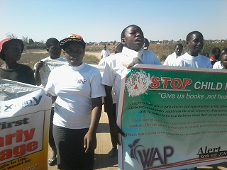
II.1. C. B. Drama by Hopley Primary School Students
In their drama, participants acted against the rampant evil practice that most African Apostolic Church Leaders uses to exploit and abuse girl children while hide behind religion and customs, a norm that is popular in Zimbabwe. Participants showed how church leaders usually abuse their position as prophets to hand-pick girls for the elderly men in the church who already have other wives. They said that this act is unacceptable and must stop. This was followed by a speech that was delivered by the Deputy Counselor. Unfortunately, we did not have a record for this speech.
II.1.D. Immediate Results or accomplishment
The implementation of this project was a remarkable achievement and tremendous success for it enabled community members to know and understand a number of challenges and consequences that are lived by victims. The event was described to be an eye opener; it permitted community members especially women and girls to open up and speak out their minds and views about child marriage.

During our appraisal questioning interview after the awareness campaign, a young lady (23) told WAP that “At my age of fourteen my father took ill and died and at the age of fifteen my mother advised me to get pregnant by my boyfriend and get married in return for bride price and financial support. Because I did not have a choice, I accepted my mother’s opinion and fell pregnant. However, this made me live a miserable life which was characterized by poverty, violence, divorce and exposure to HIV. At the age of 22, I divorced and I began living with my unemployed mother and struggling to raise my two children.

“Because of extreme abject poverty, my father and mother were not able to send all of us to school; they only managed to send my first two brothers to school up to Ordinary Level. They left me behind saying that I am a girl, one day I will be married and live with my husband. But the boy will remain in the family and will be able to take care of them. This made me turn into vending to raise money to buy food. It was a challenging occupation because most of the customers were rough and would not pay for my products,” she spoke miserably.

She went on, saying that she started selling sweets and vegetables on the street. “It was stressful to be a vendor while other children were enjoying themselves” She said. “I was only twelve when I started selling vegetables. I could carry some boxes of sweets and sit by the school gate while some of our friends whose parents could afford school fees would be coming in for lessons,”

She added that her efforts were aimed at supplementing the meager earnings his father got from the part time unskilled jobs he did for the local community members. Things turned from bad to worse when her father fell ill. His meager earnings stopped coming in and there were hospital bills to be paid. Without money for medical help, her father deteriorated quickly and he died. She continues saying, this was a big blow to the family. Only one out of the two brothers who had reached Ordinary Level had passed. Unfortunately he was still unemployed. The other brother who had failed his school examinations had joined in as vegetable vendor. As time went by, Zimbabwe’s economy began to tumble, and with it the fortunes facing her family.

“We would go for days without any basic meal. We were forced to move from one house to the other as we were failing to pay for rentals. At times our clothes and scant belongings would be thrown out by angry landlords after we failed to pay rentals. At such times we would sleep in the open, even under harsh weather,” she said.

One day when she was fifteen, a young man proposed to her. He was from the neighborhood. His family was reasonably well up and owned a house in the area. Her mother felt this was an opportunity to escape from her poverty ridden family. Her mother encouraged the relationship. She did not think twice about having sexual relations with the young man. The opinion was that if she fell pregnant, then the young man would be bound to marry her and support her and her family.

She got pregnant and her relative took her to the boyfriend’s house and demanded that the family pay dowry. For over a year, she stayed with her boyfriend. Not a cent was paid as dowry. The young man also became violent and would assault her severely. Moreover, he started having other relationships outside their marriage. He no longer cared for her. His family did nothing to help her. She was forced to do all the household chores and was not provided with food. When she realized that what she was advised as an opportunity to escape poverty had turned out to be the opposite, she approached her family to accept her back.

Now she struggles to support her two children on a daily basis and the father of the children has turned a blind eye to her suffering. After all, he is unemployed and as such she says cannot claim maintenance. After being through lots of suffering, poverty, and the inability to raise her children, she found herself sleeping around with other men. She later discovered that she was infected with HIV.

The above story does not differ from what hundreds of other young women and girls go through in Zimbabwe. Young girls in Zimbabwe are getting married at a tender age to escape poverty. Others are forced by their families, religious or cultural basis. Many families in Zimbabwe consider girls as a source of income rather than a family member. The practice of early marriages has subjected girls to acute poverty and the risk of health challenges.

According to the early Zimbabwe Multiple Indicator Monitoring Survey report state that 21% of children, mostly girls, were married before the age of 18. These marriages are not taking place in a vacuity. The survey specifies that, poverty, cultural and religious practices are the key drivers of child marriages in Zimbabwe. Though some changes were made by the Zimbabwean high court in January 2016, the minimum marriageable age under general law in Zimbabwe had always been 16 for girls and 18 for boys. Customary law, which was also part of the legal system did not have a minimum age for marriage. This loophole has ensured that perpetrators of child marriages get away with their crimes.

Some cultural practices such as kuripira ngozi (where a girl is used as compensation for a serious crime committed by her family), kuzvarira (where a girl is married off in return for financial support) and kugadzamapfihwa (where a girl is substituted for her in the event that the aunt has failed to conceive children or dies) have contributed significantly to the number of child marriages.

Religious groups also have their justifications in upholding the practice of child marriages. A chief known to be member of the African Apostolic Church was once quoted saying that “there was nothing wrong with marrying off underage girls.” Child Marriage is also prevalent among the Johanne Marange Apostolic sect, commonly known as “vapostori” who constitute approximately 1.2 million members in Zimbabwe.

In addition, women young mother who married before the age of 18 years and stakeholders in the community thanked WAP for initiating this programme. They commended Women Advocacy Project team for its endeavors in holding this awareness campaign. They said girls should be allowed to grow first, attain a good age if possible above 20 and be allowed to finish their education including university studies. This way an educated girl can be able to make her own well informed choices.

They added saying that; child marriage abolition programme should become one of the top priorities among many in the communities for its informative and educative impact. They advised that WAP should not backslide from telling community members the truth about child marriage.

II.1. B. “Give Us Books, Not Husbands” Child Marriage Abolition Campaigns in Waterfalls.
In August 2016, the Women Advocacy Project (WAP) received financial support from Rock Flower, our partner organization based in the United States of America (USA). The purpose of the grant was to support the implementation, monitoring and evaluation of the approved project “Give Us Books, Not Husbands” Child Marriage Abolition Campaign in Harare, the capital city of the Republic of Zimbabwe. On Friday 14 October 2016, the Women Advocacy Project implement a successful awareness campaign in the residential suburb of waterfalls, Harare. Based on the initial idea of the project, it was proposed that the awareness campaign will be implemented in Mabvuku – Tafara Township, a high density suburb located at about 17 km east of Harare, the capital city of Zimbabwe. However, due to some changes that occurred during the preparations as participants needed a suitable place where we could all meet together. It was later decided that we hold the event in Waterfalls, a residential suburb in the south of Harare and is where WAP’s office is located. The awareness campaign (“Give Us Books, Not Husbands” Child Marriage Abolition Campaign) was implemented in partnership with the Ministry of Women’s Affairs, Gender and Community Development (Government of Zimbabwe), The Women’s Self Promotion Movement (WSPM), a registered grassroots organization created in Harare, Zimbabwe by women from various African countries, the Child Line Zimbabwe, a child-focused, not-for-profit, apolitical, non-denominational, registered Private Voluntary Organization that provides therapeutic and educational services to children regardless of their socio-economic status or geographic location, DENMAK Training Services Zimbabwe, Mbare High school, Mabvuku Tafara High school and Upper View College and Hopley High School. The event was attended by a number of about 210 (two hundred and ten) participants, representatives from the Ministry of Women’s Affairs, Gender and Community Development, Women’s Self Promotion Movement, Child Line Zimbabwe, Principals and leaders from Upper View College, DENMAK Training Services Zimbabwe, Mbare High school, Hopley High School, Mabvuku –Tafara High school, girls and boys students, young women victims of forced early child marriage, a team of Inspired Teens from DENMAK training services Zimbabwe, Religious leaders and the Zimbabwe Republic Police Officers. Please see the banner picture below.
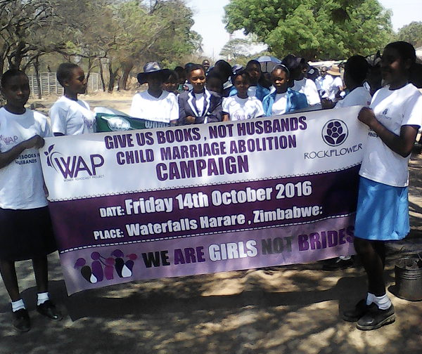
II.1.B. 1. Aim and Objectives of the Awareness Campaign.
The main aim of this event was to speak on the elimination of child marriage in Zimbabwe, Africa and the world, Inform the community effects that child marriage has impacted in the victims lives, spreading awareness to end HIV/AIDS pandemic, as well call on the Government to consider creating educational opportunities for non-schooling, and girls from poor families, and to allow the rule of law on cases concerning child marriage. In addition, the event was also meant to commemorate the International day of the Girl Child.

II.1.B.2 Activities Involved.
Due to the limited time and also significance of the activities that we had on this day, we decided to reduce some activities that were proposed in order to give priority to activities that were most central. Activities that took place during this event include:
  - A 4.6 km street walk
  - Speeches, and
  - 1 Poem
  - Distribution of Fliers
II.1.B. 3. 4, 6 Kilometer Walk
The awareness campaign began with a 4.6 kilometer street walk which covered the distance between Cheviot Shopping centre and Uplands Shopping centre in Waterfalls residential suburb. The street walk was attended by all participants including the representatives from the Ministry of Women’s Affairs, Gender and Community Development, Child Line Zimbabwe, the Women’s Self Promotion Movement, Inspired Teens Team, Pastors, young mothers’ victims of forced early child marriage, all students and Teachers present, and Zimbabwe Republic Police Officers. During the street walk, participant managed to have tête-à-tête conversations with community members residing in the areas and those who were passing in the streets giving them printed fliers and expressing the need to stop child marriage. Please, see a picture as given below.
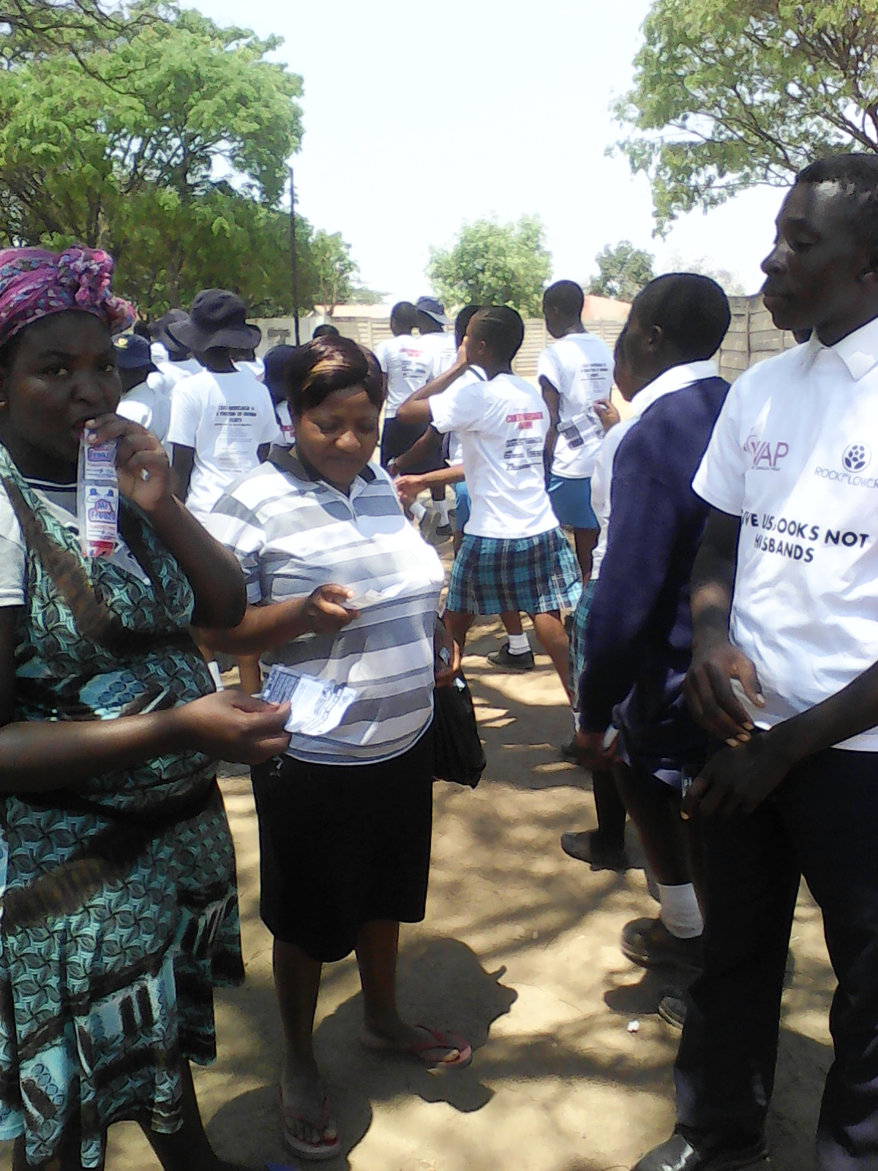
II. 1.B. 4. SPEECHES.
After the 4.6 km street walk and distribution of fliers, all participants gathered at stand number 1118 South View Road, in Uplands where the Tent was pitched. During our assembly at the tent, we listened to 6 powerful, stimulating and inspiring speeches that were delivered by the guest speakers who were invited from different organizations including the Ministry of Women’s Affairs, Gender and Community Development, Women’s Self Promotion Movement, Child Line Zimbabwe, schools, and an empowering opening remark from Mrs. Constance Mugari, the Executive Director of the Women Advocacy Project. Please see her picture below as she was addressing the audience.
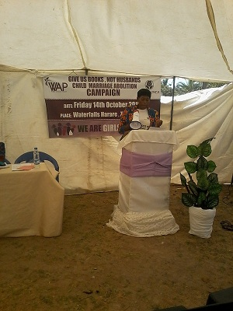
In her speech after she welcomed all members present at the event and introduced WAP, Constance went on to tell the audience that Child marriage is a reality for millions of children predominantly girls across the African continent. About 39% of girls in sub-Saharan Africa are married before their 18th birthday; while 13% are married by their 15th birthday, she said. She added saying, the impact of child marriages for girls goes beyond the obvious end to a career path. Child marriage brings an abrupt and unnatural end to a girl’s childhood and adolescence through imposing adult roles and responsibilities before she is physically, psychologically and emotionally prepared. Marriage imposes social isolation on girls, bringing unwanted separation from their friends and family. Once married, girls are most likely to feel powerless to refuse sex. Child brides find it difficult to insist on condom use by husbands who are usually older and more sexually experienced making the girls vulnerable to HIV/AIDS including other STIs. Child marriage can result in bonded labour or enslavement – a sentence to regular exposure to domestic or sexual violence and a pathway to commercial exploitation. Child brides are also under intense pressure to fall pregnant immediately after marriage presenting a major risk for both mother and the baby.
She further added that, the repercussions of marrying as a child affect girls throughout their lives. Marriage often marks the end of girl’s education, limits her economic opportunities outside the home, and exposes her to physical, sexual and emotional violence. Child marriage also threatens efforts to improve maternal health across the country and Africa as a continent. Child brides face higher risk of death and injury in pregnancy and childbirth, with girls under 15 being five times more likely to die in childbirth than women in their 20s. Their children are at risk too: when a mother is under 18, her baby is 50% more likely to die in its first year of life than a baby born by mature mother.
In concluding, Constance called on the Government of Zimbabwe to seek ways to eliminate the prevalence of child marriage in Zimbabwe, increase educational opportunities for poor and non-schooling girls living in poverty to be able to attend school through the provision of scholarship and bursaries, and harmonize all laws on the age of marriage to 18 years as stipulated by the constitution and apply stiffer penalties and sentencing of violators.
She also called on all stakeholders in Zimbabwe to reject social norms and break the cultural silence that continues to hide these violations of the rights of vulnerable children and girls in particular. For further details please, see her full speech as enclosed in the appendix.
After her speech, Mrs. Constance Mugari was followed by Mr. Joseph W. N. BOOMENYO, the programme Officer of the Women’s Self Promotion Movement with a speech focused on commemorating the international day of girl child. In his speech, Mr. Joseph said that the WSPM believes that promoting girls’ access to education, primary health care and basic human needs is critical for their empowerment and for the achievement of gender equity and equality.
Promoting girls access to education is vital because it may facilitate the achievement of a happy life and enjoyment of good things the world has to offer. A great job, a good mother and good social reputation are few of the many benefits of being an educated girl. Education is a precondition for a promising and secure future and a stable life for both girls and boys. It is also the key to poverty alleviation and may contribute to the achievement of sustainable development goals 1, 4 and 5. If you are educated you have more chances of getting a good high paying job which will also lead to a better life and financial independence.
Girls’ access to long-life education will help them to gain self- confidence, self-esteem and self-determination. Education can help girls achieve their dreams; reduce gender based violence and violence against women and girls. It may also contribute in making the world a safer and more peaceful place for all. Girls are mothers of tomorrow. As mothers, they will influence their children to go to school and enjoy same benefits that will lead to sustainable development.
We all have the obligation to promote girls access to education and other basic human needs. This can be achieved through collective cooperation and action to fight all forms of discriminations and harmful traditional practices against women and girls. We should stand with and for them in fighting and discouraging child marriages. We need to work together and provide the necessary support to ensure access to scholarships and vocational training for women and girls in urban and rural areas. We need to work together and ensure women and girls access to financial services and facilities for employment creation and poverty alleviation.
To the girls who are here present, I encourage you to believe in yourselves, fear God and work hard to liberate yourselves by aiming higher. Stay in schools, accomplish greater results. Avoid early marriages and laziness. Be strong and courageous. Honor your parents, your guardians, your teachers, authorities and lead by example. Believe in God and serve Him. The Bible says, “The fear of God is the beginning of knowledge...” (Proverbs 1:7).
He concluded by encouraging girls and boys with a Biblical word “Seek first the kingdom of God and His righteousness and all these things shall be added unto you as well” (Matthew 6:33). For further details, please see his speech as enclosed in the appendix.
Mr. Joseph W.N BOOMENYO was followed by a few other speeches which were delivered by Mrs. Manyere Sylvia Nyasha who represented the Head of Harare Province, Ministry of Women’s Affairs, Gender and Community Development, Honorable Chimboza, Mrs. Tanyanyiwa who represented the Harare Branch Manager, Child Line Zimbabwe, Mr. Richard, Mrs. Eunice Shoko who is the principal at DENMAK Training Services Zimbabwe, Mr. Brightwell Tatenda Muruko who is the principal at Upper View College, and a poem delivered by the Inspired Teens Leader Farai Gwenhe.
NB: Please note that we were not able to obtain copies of the rest of speeches and poem. Most speakers did not have written copies of their speeches. Please, use images and clips we sent you, for those who were able to receive our video clips. We are also yet to hold our evaluation meetings with the participants to find out what was the impact of the activity and hear their comments and recommendations.
III. Women’s Economic Empowerment through Raising Broiler Chickens for Households’ Sustenance Project in Marondera.
Although women constitute the majority of the population in communities we serve, (this is the case of Zimbabwe which is composed of 52% women) are still economically and financially underprivileged. Poverty in families is leading to early child marriage, premature pregnancies and early drop out of school among young girls. Young people, especially girls, in these communities grow in poor environments that further perpetuate their vulnerability and expose them to HIV/AIDS pandemic which continues to destroy family and community structures, and that affect existing support systems in families and the society as a whole.
In addition, the historical and cultural development in Zimbabwe has traditionally created a socialization process through which men and women access, gain ownership, control and use resources differently. It is a fact that men and boys have historically had greater access to opportunities and resources than women and girls. This has been at the heart of legal, political, social and economic systems that have promoted men’s dominance over women in all spheres of life. Among the major deficiencies of this system have been the following inequalities:
- Women and girls constitute a large number of the poor,
- Women are tied to the rural areas than men and remain at the periphery of human development and governance
- Women have less access opportunities to education because of cultural practices and belief.
These realities also indicates that men have continued to perpetuate harmful traditional practices such as inheriting widows, sexually abusing women and girls, using women as economic instruments and general women ‘s human rights abuses. In turn, women have become subservient victims of these negative practices due to their economic dependency on men for survival. This has given men more impetus to violate women’s rights thus causing much suffering to women.
Additional specific problems contributing to women and girls’ poverty in Harare and Zimbabwe as a whole includes
- Low Level of Education:
Many girls do not attend secondary school or do not complete their education, and some do not even attend school at all. This situation is likely to worsen due to increased household poverty in the country. As a result, many school going children are dropping out of school because parents are unable to pay school fees since the Basic Education Assistance Module (BEAM) has been disconnected.

- Declining Support Systems:
Free access to education in the first 7 years has been disconnected resulting in increased number of school drop outs. Health consultation fees have increased and many people cannot afford services anymore. Hence, families are facing more financial burden.
Most women and girls in communities we serve are particularly vulnerable in the job market because of their lack of formal education qualifications, skills and experience jeopardises their potential to gain employment in a market where jobs are already scarce. It is more challenging for many disadvantaged women to have access to opportunities to learn new skills or acquire a decent education that lead to a sustainable employment. As a result, many women and young girls are likely to remain poor if they do not have skills and receive concrete support to become self-reliant. This situation has made many women and girls to risk their lives by engaging in transactional sex and illegitimate activities which is fuelling the spread of HIV and AIDS pandemic and increases the feminization of poverty. The inability to provide for and assist one’s family further undermines self-esteem and leads to a diminished sense of identity and status.

To this end, the Women Advocacy Project attempts to change this situation by enabling women to gain hope to life and confidence through engaging in income generating project that will help them sustain their households, send their children to school and reduce the prevalence of forced child marriage. Through the support received from Stichting Overal (Netherlands), Women Advocacy Project has managed to assist 40 poor single mothers and widows from poor and low income households to venture in income generating activities through keeping and selling broiler chickens in Marondera, a district of Mashonaland East Province of Zimbabwe.

III. 1. Project Objectives.
The main objectives of this project were to:
- Enhance women’s economic empowerment through increased access to financial resources,
- Improve household food security,
- Create sustainable income means that poor single mothers and widows can successfully use to support their children’s education, and
- Promoting women’s access to ownership of properties (including land).
III.2. Proposed Project Activities:
This project is currently being implemented and most of its activities are still ongoing. For the time being, WAP has managed to complete the following activities.
- Entrepreneurship, Business Leadership and Management Training Workshop
- Selection of Income Generating Activities Groups Members
- Distribution of Start-up kits
III. 2. A. Entrepreneurship, Business Leadership and Management Training Workshop in Marondera
On 25 December, 2016, WAP, through the financial support received from Stichting Overal (Netherlands), managed to implement a one day Entrepreneurship, Business Leadership and Management Training Workshop at Marondera Hotel in Marondera Town. The training was attended by a number of 40 women single mothers and widows beneficiaries of the ongoing women’s economic empowerment trough Raising Broiler Chickens for Households’ Sustenance Project. Please see a picture as given below.
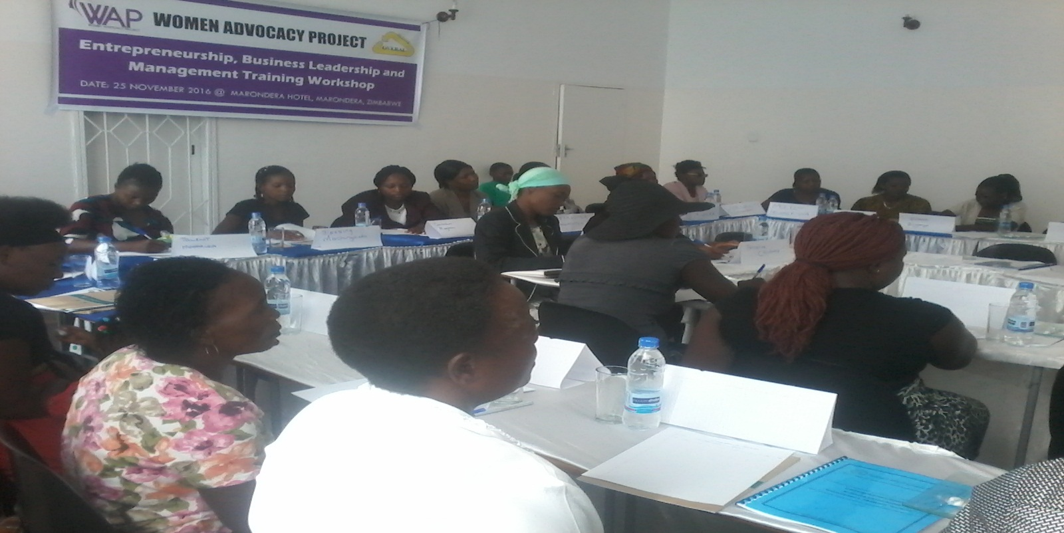
The training aimed at imparting knowledge and skills that was a felt need to enable the project beneficiaries to be more innovative, creative and at same time effectively and efficiently manage their project. The module was designed to cover a number of topics including: Poultry Management, Entrepreneurship and Team Work Principals, Capacity building (confidence building, advocacy skills, commerce, business management, and record keeping.), Marketing, and Financial Literacy.
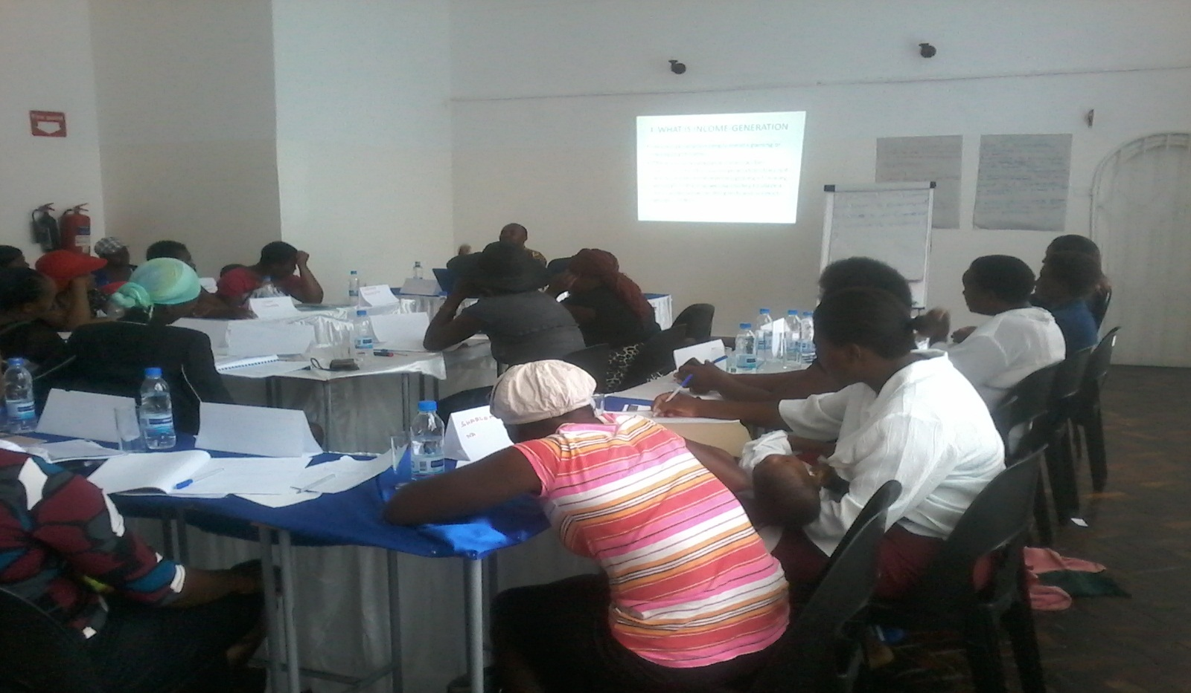

The programme was intended to be implemented in two sessions. Each attended by 20 participants in five days. However, due to limited financial resources, with more important inputs needed by the project, WAP tried not to spend much money on less necessary expenses, though there was a necessity for taking the beneficiaries through the entire module. We could only manage to introduce them to topics that were much important. We also managed to provide a hard copy for the full module to each participants for further reading and guidance.

III. 2. B. Selection of Income Generating Activities Groups Members and Distribution of Start-up kits.
After the training, WAP worked hand in hand with beneficiaries who were previously identified through our held assessment survey to select members for the 4 Income Generating Activities (IGA) Groups composed of ten (10) members each. IGA group members were selected from different high density suburbs to benefit from the activities of the project. Each group appointed its management team to lead and supervise the activities of their groups.
On 29, 30 November and 1st December 2016 WAP managed to distribute the startup kits which included 500 Chicks, 36 bags of feeds, Feeders and Drinkers, Medical supplements and One 430 Litters deep freezer to each group. Please see a picture below showing some of the inputs that were delivered. The project is currently underway. We hope to keep updating our funders on the impact and outcomes as we continue to monitor the progress of this important project.
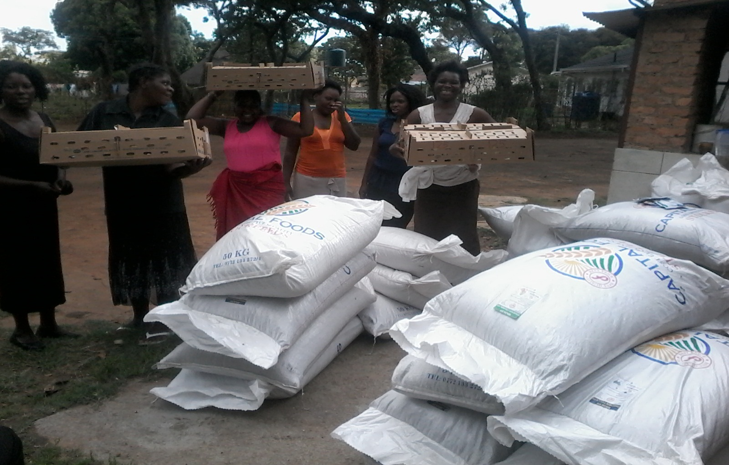

IV. Staff Development and Networking
In a quest to develop our human capacity and expand our network strategy, through the year 2016 WAP staff members attended a series programmes and activities that were organized and implemented by other sister organizations including the Ministry of Women’s Affairs, Gender and Community Development (Government of Zimbabwe), Girls Not Brides- Zimbabwe National Partners, Women’s Self Promotion Movement.

IV. 1. Commemoration of 2016 International Day for Girl Child and Launch of HE for She Campaign.
On Thursday the 27 of October 2016, in solidarity with the Ministry of Women Affairs Gender and Community Development, UNWOMEN, UNFPA, PLAN International and other sister organizations, Women Advocacy Project celebrated the launch of the He for She campaign in commemoration of the International Day of the Girl Child at Harare City Sports centre. Speaker after speaker called for an end to child marriages, child sexual abuse, and child labor... in Zimbabwe. Guardians and parents were urged to support girl child education and shun all cultural and religious practices which impede on the rights of the girl child. Below is a picture of Mrs. Constance taken during her participation at the event.
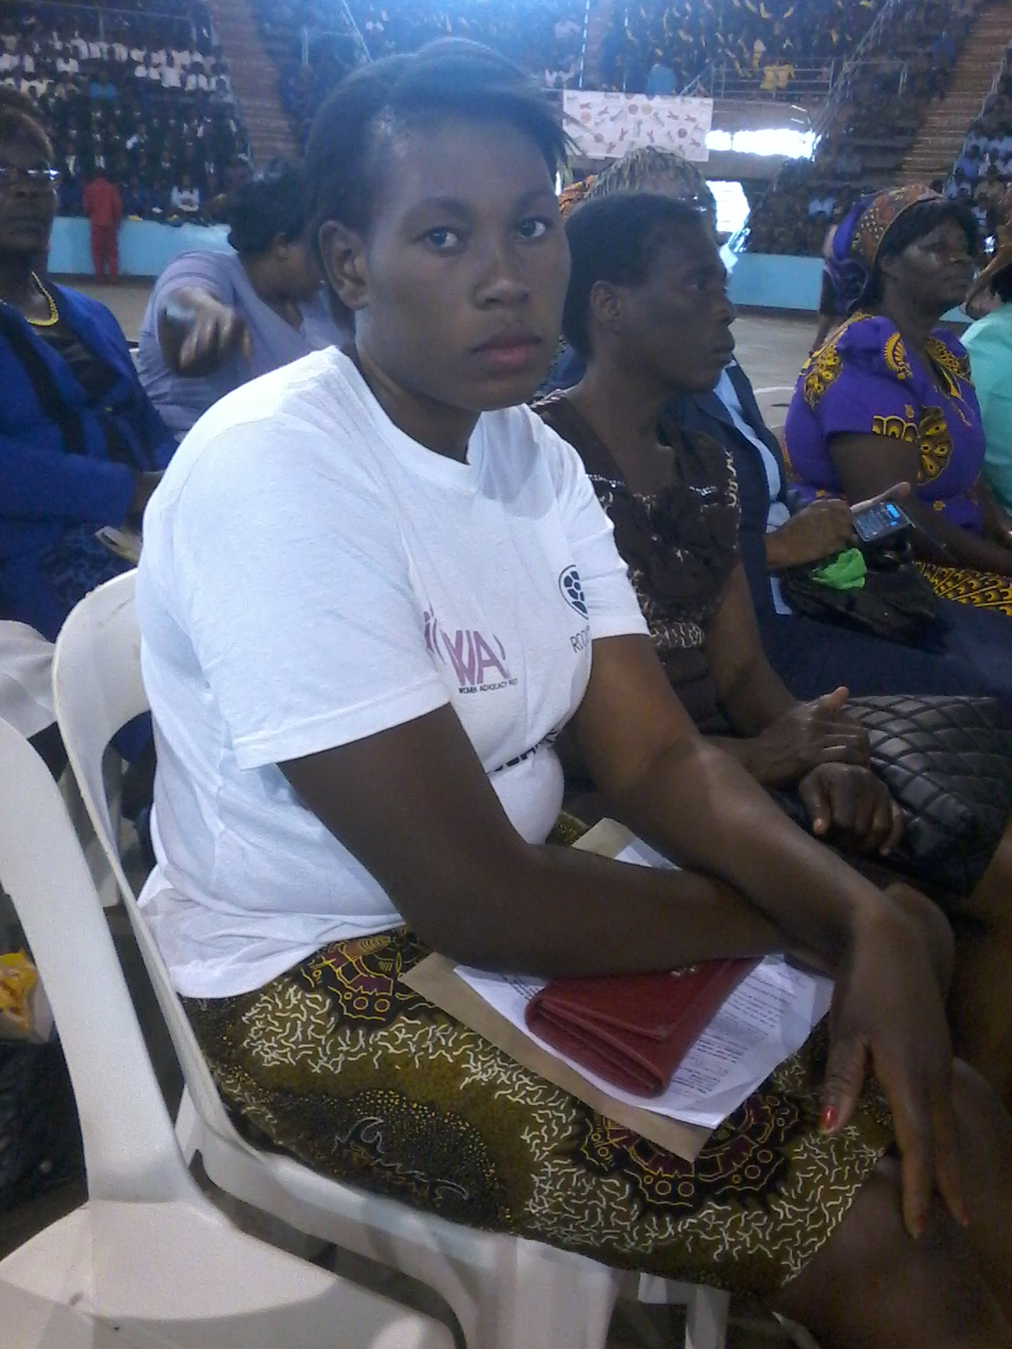

IV.2. Progress assessment and visioning workshop for the national group on ending child marriage in Zimbabwe
On 23-24 November 2016 a Women Advocacy Project delegate with representatives from other sister organizations attended a strategic planning workshop which was convened by Girls Not brides Zimbabwe at the Bronte Hotel in Harare, with the support of Girls Not Brides Global Partners. The strategic planning session was premised on the development of a strategic plan for GNB Zimbabwe members with the aim of projecting a much more institutionalized and strategic organizing for Zimbabwe around ending child marriages.

IV. 3. Women’s Human Rights and Victory Over Violence Training of Trainers in Tongogara.
On 17 – 20 August 2016, WAP representatives together with other women and girls participated at the Women’s Human Rights and Victory Over Violence training of trainers which was organized and implemented by the Women’s Self Promotion Movement in Tongogara Refugee Camp of Zimbabwe. The main aim of this training was to build the capacity of women and girls to fully participate in campaigning against gender based violence, teach and inform community members about causes and consequences of violence against women and girls and educating for safety and peace. Below is picture of the programme.
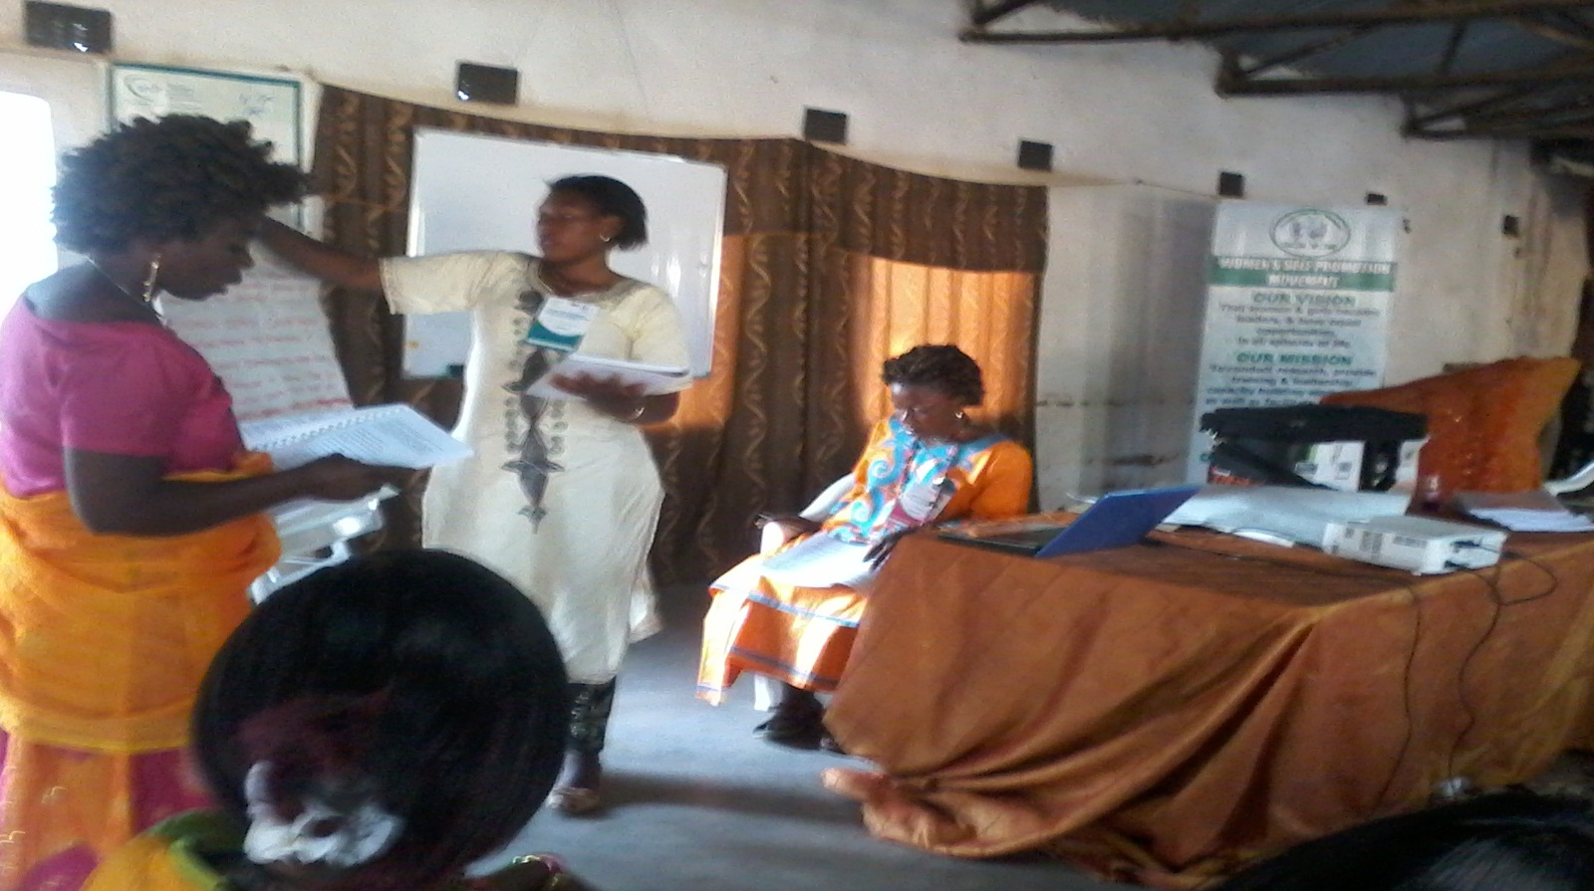

V. Challenges and Mitigation Plans

V.1. Challenges
WAP’s man challenge continued to be its still limited funding base. Although there has been much efforts in fundraising, WAP’s financial resources are still very low, funds raised have been for earmarked activities and still have not yet expanded that much. To date, the Women Advocacy Project is still struggling to develop its projects and activities.

V.2. Mitigation Plans
WAP will continue to mobilize funds, Follow up on funding possibilities from the Rock Flower (USA), Stichting Overal (Netherlands) and others; continue to build relationships and engage with (potential) funders; Raise and allocate funds to cater for its institutional development needs, including staff base, office space and purchase of relevant equipment. In addition, WAP would like to engage in income generating and revenue diversification activities for short and mid-terms financial sustainability. This may require us to invest in areas such as, land transportation which will require the availability of at least three mini buses for public transport that would be commuting in the city of Harare. We also envision operating take-a ways restaurant and initiate agricultural cooperatives, as well petit commerce for creating a reserve fund for basic operational expenses. In addition, we would like to engage in long term projects for financial sustainability and autonomy.

VI. Future Plans
In the next years, WAP plans to focus on the following key areas:

VI. 1. Strengthening our Organizational Capacity
We seek to build, develop and maintain qualified or highly performing human resources dedicated to promoting women’s rights and development so as to strengthen the organization’s capacity to effectively and efficiently run its projects and activities towards the achievement of the organization’s mandate. We believe that investing in our organization’s capacity is a key to its longevity. This will require training, mentoring, coaching and building shared vision between Board members, staff, volunteers and the organization. It will also require strategic thinking, team learning and personal mastery toward the achievement of organizational leadership development and sustainability.

VI .3 Broadening our Training Programs and Activities
Apart from our
- Awareness Raising on Stop Early Child Marriages (“Give Us Books, Not Husbands “Child Marriage Abolition Campaigns) covering part of Harare, Gokwe District, and Marondera,
- Women’s Leadership and Human Rights Training workshops aimed at providing basic and advanced leadership workshops, training of trainers, mentoring and coaching women and girls to actively participate in the decision making process that affects their lives in homes, families, work places, community and in the society, and
- Women’s Socio Economic Empowerment programmes,
The Women Advocacy Project is currently seeking for financial, material and equipment support from donors and well-wishers to help our organization establish a Vocational life skills training centre intended to enable unskilled poor women and girls from low income families to acquire practical skills that will capacitate them to become self-reliant and improve their life standards. We confident that after completing their courses, the skills that they will have acquired will make them self-sustainable and competent enough to apply or create their own jobs that will enable them to earn livelihoods and improve their financial standing to become independent and be able to support their household’s basic needs including food security, rents and children school fees.

We also want to continue with the implementation of the above mentioned programmes, as well providing seed support and revolving credits facility to low-income and marginalized women and girls entrepreneurs to create self-help jobs by venturing in small projects namely poultry breeding, goat keeping, farming, food processing and dress making;. Please help us to help them.

WOMEN ADVOCACY PROJECT’S STATEMENT OF COMPREHENSIVE INCOME FOR THE YEAR ENDED DECEMBER 2016

AMOUNT VALUED IN UNITED STATES DOLLARS
Source of Income | Amount in United States Dollars
External Sources of Income
Stichting Overal (Netherlands) | $ 9,683.97
Rock Flower (USA) | $ 5,000.00
Alert Fund for Youth (Netherlands) | $ 1,380.00
X min Y Solidarity Fund (Netherlands) | $ 1,076.00
Total Receives | $17,139.97
Internal Sources of Income
Members’ regular monthly contribution | $ 2,175.00
Sales of products and services | $ 3,725.00
Churches donations | $ 454.00
Well-wishers (both cash and in kind donations) | $ 1,023.00
Balance year end 2015 | $ 1,090.00
Total Internal income | $ 8,467.00
Total Annual Income | $ 25,606.97
Expenses
Women’s Economic Empowerment through Raising Broiler Chickens for Households’ Sustenance in Marondera | $ 13,120.00
Two Awareness Raising on Stop Early Child Marriages (“Give Us Books, Not Husbands “Child Marriage Abolition Campaigns) | $ 9,055.00
Office Rental | $ 2,880.00
Consumables | $ 85.00
Bank Charges | $ 185.00
Total | $ 25,325.00
Balance Available | $ 281.97

Appendix 1.
1.1. Opening Remark by the Women Advocacy Project’s Executive Director
The Head of Harare Province, Ministry of Women Affairs, Gender and Community Development.
Honourable. CHIMBOZA

The Programme Officer, Women’s Self Promotion Movement
Mr. Joseph Williams Boomenyo

Harare Branch Manager, Child Line Zimbabwe
Mr. Richard

The Head Master, Upper View College
Mr. Muruko

All Pastors Present

Ladies and Gentlemen

Good morning,

It is both a privilege and honour to be able to introduce you to our organisation and the programme we are implementing today.
The Women Advocacy Project is a registered non-governmental and not for profit making Trust for women and girls empowerment formed in 2012 in the city of Harare. The organization was created by a group of women and girls from different communities of Harare. WAP was established after the realisation of inadequate attention given to the issues that are affecting women and girls. The organisation is committed at promoting and protecting the rights of vulnerable and marginalized women and girls in communities through holding advocacy campaigns and lobbying for the right of voiceless women and girls. WAP also seek to promote women’s socio-economic rights through the implementation of economic empowerment projects.

Our Vision: WAP’s vision is a society where women and girls realize, enhance and maximize their social, cultural, economic and political potential as citizens of Zimbabwe.

Our Mission: WAP’s fulfills its mandate through holding advocacy campaigns on women’s human rights, provide training and leadership capacity building workshops and facilitating economic empowerment for disadvantaged and marginalized women and girls in Zimbabwe.

Today we are here to join hands in fighting the prevalence of forced or early Child Marriage situation in Zimbabwe, Africa and the World as a whole.
Child marriage is a reality for millions of children – predominantly girls across the African continent. It is said that about 39% of girls in sub-Saharan Africa are married before their 18th birthday; while 13% are married by their 15th birthday.
The impact of child marriages for girls goes beyond the obvious end to a career path. Child marriage brings an abrupt and unnatural end to a girl’s childhood and adolescence through imposing adult roles and responsibilities before she is physically, psychologically and emotionally prepared. Marriage imposes social isolation on girls, bringing unwanted separation from their friends and family. Once married, girls are most likely to feel powerless to refuse sex. Child brides find it difficult to insist on condom use by husbands who are usually older and more sexually experienced making the girls vulnerable to HIV/AIDS including other STIs. Child marriage can result in bonded labour or enslavement – a sentence to regular exposure to domestic or sexual violence and a pathway to commercial exploitation. Child brides are also under intense pressure to fall pregnant immediately after marriage presenting a major risk for both mother and the baby.

In addition, the repercussions of marrying as a child affect girls throughout their lives. Marriage often marks the end of girl’s education, limits her economic opportunities outside the home, and exposes her to physical, sexual and emotional violence.
Child marriage also threatens efforts to improve maternal health across the country and Africa as a continent. Child brides face higher risk of death and injury in pregnancy and childbirth, with girls under 15 being five times more likely to die in childbirth than women in their 20s. Their children are at risk too: when a mother is under 18, her baby is 50% more likely to die in its first year of life than a baby born to older mothers.
According to a report presented by the Research and Advocacy Unit, it is predicted that if present trends continue, 142 million girls worldwide will marry before they reach the age of 18 over the next decade; that is 38,000 girls married every day for the next 10 years. The issue of child marriage has become one of the world’s focal areas in addressing the rights of children. This is because child marriage is believed to have far reaching consequences for the girl child’s rights to education, health, reproductive and sexual rights, as well as the right to be free from violence. Child marriage is also considered as a form of violence posing a threat to public health, social welfare, human rights, and economic development. In Zimbabwe, a recent study revealed that 31% of girls are married before the age of 18. According to the 2013 Multiple Indicator Africa Scorecard on Girls and Women’s Reproductive Health, Family Planning and Human Development which underlines linkages between contraceptive prevalence fertility rates per woman, forced marriage of under-age girls and under-age birth, Zimbabwe’s performance is very worrying as the situation seems to be getting worse. Zimbabwe’s ranking - by countries with the highest number of underage girls who get married - has moved from position 27 in 2012 to 21 in 2013, indicating a large increase in the number of girls who get married before they turn 18. These are startling figures, calling for an urgent intervention to safeguard our future generation of women.

In conclusion, the Women Advocacy Project would kindly like to call on the Government of Zimbabwe to seek ways to eliminate the prevalence of child marriage in Zimbabwe, increase educational opportunities for poor and non-schooling girls living in poverty to be able to attend school through the provision of scholarship and bursaries, and harmonize all laws on the age of marriage to 18 years as stipulated by the constitution and apply stiffer penalties and sentencing of violators.
WAP would also like to call on all stakeholders in Zimbabwe to reject social norms and break the cultural silence that continues to hide these violations of the rights of vulnerable children and girls in particular
I thank you.

2. Speech by the Programme of Officer for the Women’s Self Promotion Movement

CELEBRATION OF INTERNATIONAL DAY OF GIRL CHILD
14 OCTOBER 2016 CITY OF HARARE, REPUBLIC OF ZIMBABWE.
ORGANISED BY WOMEN’S SELF-PROMOTION MOVEMENT (WSPM/WLP ZIMBABWE) AND WOMEN’S ADVOCACY PROJECT (WAP) IN COLLABORATION WITH THE MINISTRY OF WOMEN’S AFFAIRS, GENDER AND COMMUNITY DEVELOPMENT HARARE PROVINCE

PAPER PREPARED AND PRESENTED BY JOSEPH BOOMENYO
PROGRAMME OFFICER FOR WSPM
BSc. Rural and Urban Planning (University of Zimbabwe)
MA. Leadership and Management (University of Zimbabwe-ALMA)
Executive Master in Peace and Governance (Africa University)

I. INTRODUCTION
- The Head of the Ministry of Women’s Affairs, Gender and Community Development Harare Province, Mr. Chibonza
- The Director of Women’s Advocacy Project
- The leaders of schools, respected teachers and students
- Religious leaders
- Leaders of NGOs
- The Zimbabwe Republic Police Officers,
- The Director of Ceremony
- All Protocols Observed
We have gathered here today to celebrate the International Day of the Girl Child, which is internationally observed on the 11th of October.
The United Nations Convention on the Rights of the Child defines a child as any person below the age of 18.
Women’s Self-Promotion Movement is a registered non-governmental organisation formed in 2001 and it is committed at empowering the disadvantaged and marginalised women and girls in the society. We work with Zimbabweans women, girls and refugees in Zimbabwe, Zambia, and Tanzania and in the Democratic Republic of Congo (DRC). We work in close collaboration with the Ministry of Women’s Affairs, Gender and Community Development and the Ministry of Small and Medium Entreprises and Cooperative Development. We also collaborate with various civil society organisations and women’s empowerment groups.
WSPM work focuses on helping women and girls to help themselves. We achieve our aim through the promotion and provision of long life education and training, leadership training and training of trainers, women political participation capacity building, life skills development and computer training, advocacy for women’s human rights and facilitating women and girls economic empowerment.
So far our organisation has directly contributed to the empowerment of over 10,000 disadvantaged women and girls who have benefited from our programmes in Victoria Falls, Bulawayo, Mutare, Harare, Marondera, Chiweshe, Tongogara Refugee Camp and in other countries as above mentioned.
WSPM believes that promoting girls’ access to education, primary health care and basic human needs is critical for their empowerment and for the achievement of gender equity and equality.
Promoting girls access to education is vital because it may facilitate the achievement of a happy life and enjoyment of good things the world has to offer. A great job, a good mother and good social reputation are few of the many benefits of being an educated girl. Education is a precondition for a promising and secure future and a stable life for both girls and boys. It is also the key to poverty alleviation and may contribute to the achievement of sustainable development goals 1, 4 and 5.
If you are educated you have more chances of getting a good high paying job which will also lead to a better life and financial independence.
Girls’ access to long-life education will help them to gain self- confidence, self-esteem and self-determination. Education can help girls achieve their dreams; reduce gender based violence and violence against women and girls. It may also contribute in making the world a safer and more peaceful place for all.
Girls are mothers of tomorrow. As mothers, they will influence their children to go to school and enjoy same benefits that will lead to sustainable development.
We all have the obligation to promote girls access to education and other basic human needs. This can be achieved through collective cooperation and action to fight all forms of discriminations and harmful traditional practices against women and girls. We should stand with and for them in fighting and discouraging child marriages.
We need to work together and provide the necessary support to ensure access to scholarships and vocational training for women and girls in urban and rural areas. We need to work together and ensure women and girls access to financial services and facilities for employment creation and poverty alleviation.
To the girls who are here present, I encourage you to believe in yourselves, fear God and work hard to liberate yourselves by aiming higher. Stay in schools, accomplish greater results. Avoid early marriages and laziness. Be strong and courageous. Honour your parents, your guardians, your teachers, authorities and lead by example. Believe in God and serve Him. The Bible says, “The fear of God is the beginning of knowledge...” (Proverbs 1:7).
Let me conclude with these words, “Seek first the kingdom of God and His righteousness and all these things shall be added unto you as well” (Matthew 6:33).
I thank you.

